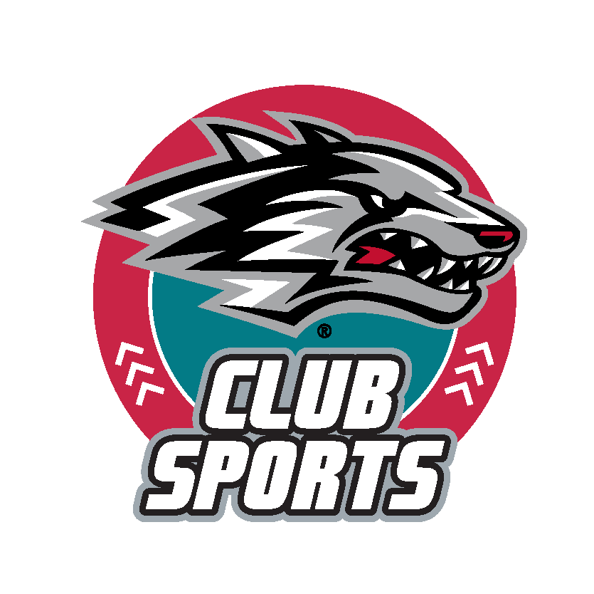

UNM Recreational Services Club Sports Guide

Contacts

Victoria Crawford-Perez,
Club Sports Coordinator Specialist
missvperez@unm.edu
(505) 238-9627

Gabe Olivas,
Club Sports Assistant
golivas06@unm.edu
(505)-369-6326

Table of Contents

Common Abbreviations 4
Useful Links 4
Marketing: 4
Contact UCAM: 5
Social Media 5
UNM Events Calendar 5
Chartering Guide 6
Getting Started 6
Running Your Club 7
Club Sports Recommended Timeline 8
Fall Semester (August-December) 8
Spring Semester (January-May) 9
Budgeting and Finance for Competitive Clubs 10
Getting Funded 10
General Guidelines: 11
Budget Rules 12
Other Important Information 13
List of Don’ts 15
List of Do’s 16
Budgetary Violations 17
Tier 1 - First Violation: 17
Tier 2 - Second Violation: 17
Tier 3 - Third Violation: 17
Tier 4 - Subsequent Violations: 17
Branding and Logos 18
Beginning the creation of promotional items 18
Logo Usage 19
Approved UNM Logo Usage 19
Unapproved UNM Logo Usage 19
UNM Brand Colors 20
Primary Colors 20
Secondary Colors 20
Disciplinary Actions 21
Types of Violations 21
Minor Infractions (typically first offenses or administrative oversights): 21
Major Infractions (more serious or repeated behavior): 21
Severe Infractions (threaten program integrity or safety): 21
Consequences Framework 22
Minor Infractions 22
Major Infractions 22
Severe Infractions 22
Appeals Process: 22

Common Abbreviations
- Recreational Services (RS)
- Club Sports (CS)
- Associated Students at the University of New Mexico, Undergraduate Student Government (ASUNM)
- Graduate & Professional Student Association, Graduate Student Government (GPSA)
- Student Activities Center (SAC)
- Student Government Accounting Office (SGAO)

Useful Links

Rec Services:
- Club Sports Resources
  - https://recservices.unm.edu/recreation/club-sports/club-resources.html

Marketing:
- General help (you'll see a red button for the brand style guide there, too):
  - https://brand.unm.edu/
- Brand Training (for fonts)
  - https://brand.unm.edu/brand-support/brand-training.html
- Logo training (for logos)
  - https://brand.unm.edu/brand-support/brand-training.html
- Free monthly brand lab hours:
  - https://brand.unm.edu/brand-support/brand-training.html
- Web accessibility guidelines, free headshots, and more:
  - https://brand.unm.edu/brand-support/creative-resources.html
- Campus digital sign submission form:
  - https://brand.unm.edu/digital-signage/digital-sign-submission-form.html
- Sign up for monthly MarComm meetings:
  - https://brand.unm.edu/marcomm/index.html
- Trademarks & Licensing:
  - https://brand.unm.edu/logos/licensing-merchandise.html
- Club Sports Badges and Logos
  - https://drive.google.com/drive/folders/1LIUxRBGmelUZFr1vrUM7lH12rgHDdlbW

Contact UCAM:
- Reach out to any team (marketing, communications, social, and web) at UCAM:
  - https://ucamsupport.unm.edu/home/
- Submit a design review:
  - https://brand.unm.edu/brand-support/design-review.html
- Submit a marketing request:
  - https://brand.unm.edu/brand-support/marketing-request.html
- Submit a Creative Services request for a photo/video/design project:
  - https://brand.unm.edu/brand-support/creative-services.html

Social Media
- Social media posting request:
  - https://social.unm.edu/posting-request.html
- Sign up for monthly SMUG meetings (social media users group)
  - https://social.unm.edu/user-group/index.html
- Lobo POV application:
  - https://forms.unm.edu/forms/lobopov_application
- Social media guidelines:
  - https://social.unm.edu/guidelines/index.html

UNM Events Calendar
- UNM events calendar:
  - https://unmevents.unm.edu/
- How to submit to the UNM events calendar:
  - https://ucam.unm.edu/events/index.html

Club Sports at UNM

What is a Club Sport?
Club Sports are student-led organizations created to provide athletic participation in a non- NCAA capacity. Teams can either be competitive or recreational, and compete and play against other organizations, clubs, colleges, and universities in their respective conferences. At UNM, Club Sports operate under Recreational Services and are automatically members of the Sport & Recreational Club Council that’s there to support them and enhance athlete’s experiences. They also work closely with the Club Sports staff in the department to ensure their clubs are running properly and in compliance with university policies, rules, and regulations.

How many teams are there?
There are 14 active Club Sport teams. Of these 14, 9 are competitive, with the other 5 being recreational. If you’re interested in trying or continuing to play a sport there’s not currently chartered, you’re more than welcome to start one (steps outlined in the following guide). All you need is yourself and at least 5 other people, and it’s relatively simple to do.

Chartering Guide
Congratulations on making the decision to charter a Club Sport team, and welcome to the Council! We’re happy to have and look forward to working with you. The chartering process involves several different steps but will result in you being recognized as an official team, automatic eligibility to receive funding from Rec Services, the ability to hold regular practices, and membership in the Sport & Recreational Club Council (S&RCC), to name a few. Email Victoria at missvperez@unm.edu with any questions.

Getting Started
- Have a minimum of five (5) students interested in joining your Club Sport team.
- Ensure at least two (2) officers attend a Charter Workshop hosted by Student Activities (chartering season is early every fall and spring semester). The dates and times of offered sessions will be posted at this link.
- Submit your group’s charter online via Symplicity, SAC’s charter system (will require you to create an account).
- Ensure all current and prospective members fill out the Player Participation Agreement prior to participation.
- Ensure at least two (2) officers attend an orientation hosted by Recreational Services. See here for a past example of what our handout looks like, we update them every semester with correct dates.
- You can now begin organizing the group’s internal affairs!

Running Your Club
Now that you’re chartered, there are a few things you should do next to ensure your group will be run successfully and effectively. Don’t feel the need to follow these steps exactly in order, since some of them involve certain aspects to be completed as a prerequisite prior to completion.

- Fill out the Updated Forms & Documents submission for your team.
- Let us know whether you’d like to be recognized as a recreational or competitive club. Competitive clubs will need to look into securing a coach and finding games and tournaments to play in, etc.
- Create an account (if one is not already made for your club) on RecWeb, our equivalent of Simplicity. Upload a group logo to be displayed on the website so prospective athletes can see it.
- Formally elect and keep record of your team’s Executive Board. Feel free to add positions depending on your team’s needs and have the President and Vice President begin delegating tasks.
- Most team’s Executive Boards begin with the roles of President, Vice President, Treasurer, and Secretary.
- Supplemental roles may include Equipment Manager, Recruitment Chair, Social Media Manager, Event Coordinator, etc.
- Have your secretary create an account on EMS to reserve space and times for practices.
- Begin drafting your group’s bylaws and constitutions using SAC’s templates, found here.
- Familiarize yourself with documents and resources from both Rec Services and SAC, and bookmark so they’re easy to access.
- SAC’s Student Org Handbook is always great
- Here’s the Club Sport website, and a wealth of helpful handouts
- Plan on attending an upcoming Sport & Rec Club Council meeting to start getting to know your fellow Club Sport athletes and leadership!

Club Sports Recommended Timeline

Fall Semester (August-December)

August
- Charter, if you haven’t already.
- Sign up for tabling opportunities through NSO in the first couple of weeks of the semester (Welcome Back days, FNL, Club Sports Day)
- Start working on your club’s budget application (competitive sports).
- Reserve practice space in EMS for the semester.
- Finalize travel/away schedule.
- Start thinking of and putting together designs for team uniforms and apparel.
- Begin fundraising plans and gather a list of potential sponsors.

September
- Submit budget application by due date.
- Attend monthly Sport & Rec Club Council meeting.
- Hold a monthly Executive Board meeting, define and solidify positions and the responsibilities for each, review and revise Constitution and Bylaws if and as needed.
- Begin scheduling fundraising events through the year. Ensure sponsor list has been sent for review, once reviewed list is approved begin reaching out to sponsors.

October
- Attend monthly Sport & Rec Club Council meeting.
- Hold a monthly Executive Board meeting.
- Have your President elect Captains with your coaching staff if not done previously.
- Order team uniforms and apparel.

November
- Attend monthly Sport & Rec Club Council meeting.
- Evaluate fundraising and recruiting efforts and initiatives, and make adjustments as needed.
- Hold a monthly Executive Board meeting.

December
- Attend monthly Sport & Rec Club Council meeting.
- Hold a monthly Executive Board meeting.
- Evaluate the state of your team’s budget and make adjustments as needed (fundraising initiatives to increase self-gen balance, etc.).
- Plan for Lobo Lair closure (mid-December through early January)

Spring Semester (January-May)

January
- Attend monthly Sport & Rec Club Council meeting.
- Take a look at when Spring NSOs will be and plan tabling/recruitment opportunities.
- Hold a monthly Executive Board meeting.
- Finalize travel/away schedule.
- Consider bringing in supplemental roles based on what went well and what didn’t last semester (photographer, videographer, etc.).

February
- Decide if you and your team would be interested in having an office in Lobo Lair for the next school year (two semesters).
- Attend monthly Sport & Rec Club Council meeting.
- Hold a monthly Executive Board meeting.
- Have your President elect Captains with your coaching staff if not done previously.
- Space allocation applications for an office in Lobo Lair are due late this month

March
- Consider all who’s graduating and who they may hand off leadership positions to. Have soon-to-be-graduates begin training the next person in their roles, (typically overseen by the President).
- Start getting things together to reserve an office in Lobo Lair
- Attend monthly Sport & Rec Club Council meeting.
- Evaluate your budget and consider the changes you’ll need/want to make and request for next year.
- Hold a monthly Executive Board meeting.

April
- Attend monthly Sport & Rec Club Council meeting.
- Start making initial adjustments to account for changes you’d like to see in your team’s budget.
- Hold a monthly Executive Board meeting.

May
- Confirm with SAC that your team’s office space is secure.
- Have all proposed changes in the budget approved by your Executive Board ready for next fall.
- Hold a monthly Executive Board meeting and elect new officers for next semester.
- Submit yearly report to Rec Services

Budgeting and Finance

Getting Funded
- Get Chartered
- Only chartered Club Sport teams at the University of New Mexico are eligible to receive funding from Recreational Services
- To become chartered, schedule a meeting with Victoria Crawford-Perez, (Club Sports Coordinator) at missvperez@unm.edu or call (505) 925-8500
- All of the following steps are required to complete your charter, please plan accordingly and pay close attention to dates!
- Attend a SAC Chartering Workshop & Recreational Services Orientation
- All Club Sport teams who intend to receive funding from Recreational Services must have at least two (2) officers attend these mandatory events, offered July-September at a variety of times
- The two required officers don’t have to be at the same meetings, but funds cannot be accessed until both people have attended both
- Have all members complete the Player Registration Participation Agreement
- For safety and liability purposes, every Club Sport athlete must complete this agreement to assume risk and understand that they are representing the university
- Fill out and submit the Updated Documents & Forms Questionnaire
- Club Presidents will submit roster, schedule, and practice information on behalf of their group
- Meet with team leadership to plan out the season
- Create a detailed plan for the upcoming season , outlining all travel, events, purchases, equipment, etc.
- Submit a Signature Authorization Form
- Every authorized signer must be on-file with Rec Services by filing out a Signature Authorization Form
- Form must be renewed every July 1st
- Submit Budget Request
- Start this process early! Don’t rush the application.

General Guidelines:
- Club sports are primarily self-supported. The University will provide a limited amount of financial assistance through Recreational Services. All other expenses must be covered by the club through member dues, fundraising events, gifts, donations, and sponsorships.
- All purchases must be made through Rec Services. All purchases not made by Rec Services must be approved prior to the purchase, or reimbursement may not be granted.
- Unspent money at the end of the fiscal year does not carry forward to the following year.
- All money that the club collects must be deposited into the club’s Self Gen account through Recreational Services. No club may have any other bank account off-campus.
- Club officers are responsible for seeing that expenses do not exceed income and that allocated funds are spent according to the University budget policy.
- Stay within your budget. Spend and track your money carefully.
- All expenditures should have a direct and positive impact on your club.
- Every purchase must be accompanied by an explanation and a description of the purpose for which it is being made.
- Document all income and expenses on a spreadsheet or other budgeting software. Informal documentation is not appropriate and will not be accepted.
- The Club Sports Coordinator must approve all expenditures and reimbursements. Plan and submit all quotes, invoices, etc., to Rec Services no later than two weeks in advance.
- Secure and submit official company receipts for all expenditures. All receipts should be itemized and have the last 4 digits of the card used.
- Reimbursements should be made within two weeks of the purchase.
- Record all income received, including the date, amount, and person making payment. Submit any income as soon as possible to Rec Services.
- Any club that ends the school year with outstanding bills will not be funded the following year and will become inactive until all outstanding bills are paid.

Budget Rules
Funding Request | Maximum Amount Available
Professional services | Up to 75% of total cost, limit once per semester
Coaching Stipend | - $235 per practice and home games  - $100 per away trip  - Maximum amount Recreational Service will cover is $1,800 per semester  - Remember, the Club can pay the coach more from their Self-Generated funds if they choose to
Away travel (overnight stays for up to 10 consecutive days) | - $250 per hotel room, up to 8 rooms  - 1 meal per day per athlete, per diem rate
Day trips (no overnight stays) | - $250 per day for less than 10 traveling athletes  - $350 per day for more than 10 traveling athletes
Travel - gas mileage | 65.5 cents per mile for up to two (2) vehicles
Travel - airfare | Up to 75% economy fare (two airline quotes must be provided). Airfare may not exceed the cost of alternate ground transportation, for which an estimate must also be provided
Advertising | $300, limit once per semester
Food and refreshments (meetings) | $300 for two semesters
Food and refreshments (events) | $1,000 (only for events without significant UNM students in attendance. Events with more community members than currently enrolled students will receive funding based on anticipated student attendance).
Promotional and incentive items | Up to $300, three quote(s) must be provided and approved

Other Important Information
Per the Chartered Student Organization (CSO) Policy:
Organizations receiving funding from the university must follow the fiscal policies and procedures of the university. In addition, organizations receiving ASUNM and/or GPSA funding must follow fiscal guidelines developed by the Student Government Accounting Office.
Per UNM Policy 7200, 1.4:
Chartered Student Organizations that receive funding from the University must deposit all funds that they collect in an internal University account.
If your organization has an off-campus bank account and wishes to continue receiving funds from the university, you will need to close the account immediately, provide proof of the closure, and deposit any funds to Recreational Services.
From now on, all services will be done in-house for competitive CS teams
- As such, competitive teams are ineligible to receive funding from ASUNM or GPSA
- Chartering, banking, and handling money are now all done through RS and not SAC
Unallowable Expenditures:
- Political contributions to individuals or organizations
- Payments to UNM employees outside of payroll
- Awards/Gifts to UNM employees
- Gifts to students
- Personal expenses
- Alcohol
- Banned substances
Gift Cards/Incentives:
While the university does not prohibit these types of purchases, it does have the following limitations associated with them:
- Gift cards MUST be purchased by Recreational Services. We CANNOT reimburse purchases for a gift card.
- Gift cards CAN NOT be given to University employees or individuals NOT associated with UNM , e.g., guest speaker in lieu of Honorarium payment
- There must be a specific business purpose associated with these purchases.
- E-gift cards are NOT an option
- All gift cards are tracked when handed out. (`Name, phone #, address)

Coaches:
All coaches must first complete a Coaches Agreement form before assuming the role as a club’s coach. Both the Club and the coach should be aware that any financial contributions to the club are strictly voluntarily, and the coach is receiving any financial advancements, nor reimbursements for their contributions. Coaches should not have any involvement with the club's business, administration, or financial matters. The coach’s payment should be decided solely by the club itself.
- If clubs would like to pay their coaches, Recreational Services must be invoiced for the coaching services
  - These invoices should be sent to Recreational Services monthly
  - Invoices should include:
    - Dates of service (day, time)
    - Location of services
    - Rate of service
  - The pay rate must be reasonable
  - Please use the following as an example
- Coaches should complete a W9 and turn it into Recreational Services

List of Don’ts
- Don’t sign any contracts
  - All contracts must be signed by Victoria Perez
- Don’t spend any unapproved funds
  - You must spend according to your budget, no exceptions
- Don’t pay taxes on goods
  - UNM is a tax-exempt organization. Recreational Services cannot reimburse taxes paid on goods.
- Don’t make any purchases on your own
  - All purchase orders should be submitted through our Recreational Services Club Sports Account System
  - All purchases must be approved by Club Sports Coordinator
  - All purchase orders must first be approved by two authorized signers
  - All purchases will be made by Recreational Services
- Don’t use your personal address for any shipments
  - All orders should be delivered to Recreational Services
  - Recreational Services address is:
    - 1 University of New Mexico MSC04 2600 – Johnson Center Albuquerque, NM 87131
- Don’t hold onto Club self-generated funds
  - Funds should be turned into Recreational Services within 1 week
  - Upon turning in funds, you will receive a receipt of the deposit
  - Ensure that the amount on receipt is correct
- Don’t take sponsorships without thanking donors
  - A thank-you note should always be sent to donors within 1 week of receiving the donation
  - This is crucial not only to show professionalism and appreciation but also to create longevity with the donor
- Don’t place orders directly with UNM SUB Catering
  - Recreational Services must place these orders for you
- Don’t purchase gift cards
  - Recreational Services is required to make these purchases for you. We cannot purchase e- cards.
- Don’t try to buy alcohol
- Don’t confuse Honorarium with Professional Services
  - An honorarium is a nominal payment as a courtesy for a university visit.
  - Professional Services are identified as services provided for a standard fee.
- Don’t offer gift cards in lieu of an Honorarium payment
  - UNM must report honorarium payments to the payee and the Internal Revenue Service (IRS) on Form 1099.
  - Payment to foreign persons is subject to 30% U.S. Federal tax withholding
- Don’t hire consultations/consulting services

List of Do’s
- Do submit purchase requests at least two weeks prior to the date the item is needed
  - Purchase must be approved by multiple parties, purchase requests submitted just a few days before needing the item will not be approved
- Do plan your season and season expenses in advance
  - Sit down with necessary team leadership and plan all events for the season prior to submitting budget requests.
- Do keep track of all your club’s purchases
  - Start an excel sheet with all your club’s expenses and keep it up to date
- Do save (or take photos of) ALL receipts for an/all purchases

Budgetary Violations
The following disciplinary tier procedure is designed to ensure adherence to the rules and regulations set forth by our club sports program. Violations of the rules will result in progressive disciplinary actions, with the ultimate consequence being the forfeiture of the entire award.

Tier 1 - First Violation:
- Upon the first violation of the rules, the offending team will receive a 10% reduction of their approved budget amount.
- The team will be notified of the violation and the corresponding reduction in their budget allocation.
- A meeting may be scheduled with the team captain or representative to discuss the violation and reinforce the importance of adherence to the rules.

Tier 2 - Second Violation:
- If a team violates the rules for the second time, they will incur a 20% reduction of their approved budget amount.
- The team will be informed promptly about the second violation and the consequent reduction in their budget.
- A mandatory meeting will be scheduled with the team captain or representative to address the recurring issue and emphasize the significance of compliance with the rules.

Tier 3 - Third Violation:
- Upon the third violation of the rules, the team will face a 30% reduction of their approved budget amount.
- The team will receive immediate notification of the third violation and the resulting reduction in their budget.
- A formal meeting will be held with the team captain or representative, along with program administrators, to discuss the repeated infractions and consequences.

Tier 4 - Subsequent Violations:
- If a team continues to violate the rules beyond the third instance, they will risk forfeiting their entire award.
- The team will be notified of the potential consequences, including the complete loss of funding.

Branding and Logos
Club Sports teams are permitted to incorporate UNM logos on uniforms as desired. This is an abbreviated guide that’s been tailored to the needs of Club Sports teams. Please refer to UCAM’s full Brand Guide, (found here), as needed. All designs must receive approval prior to placing any apparel or uniform order in accordance with your team’s budget. If you have any questions, please email Victoria Perez at missvperez@unm.edu.
Notes:
- If you intend to purchase items with a funding award from Rec Services, you must include the word “Club” before the name of your sport, (ex. “Club Tennis” instead of “Tennis”)
- If your team is planning on purchasing with self-gen funds, you don’t have to include the word “Club”, so long as your designs receive UCAM approval
- Club Sport badges are pre-approved and encouraged to be used and worn

Beginning the creation of promotional items
- Find a UNM-licensed vendor from which you’d like to purchase. Using only The University of New Mexico Licensed Vendor list.
- Designate member(s) from your team to create designs. Alternatively, you can reach out to a UNM Licensed vendor you would like to purchase from and work with them to create a mockup.
- Reach out to the vendor to create a quote for your items, ensuring the price is within your Club’s budget.
- Work off this guide and/or UCAM’s full Brand Guide, following the guidelines to the best of your ability.
- Submit all mockup designs to UCAM in a Marketing Request form at this link.
- Continue adjusting as needed until you get UCAM approval.
- Once you have received the approved design from UCAM, begin creating your purchase order in the Recreational Services Account System.
- Include all mockup of your items
- Include the approval email from UCAM
- Include quote or invoice of items
- Wait for final approval from Victoria and confirmation of your items being purchased.

Logo Usage

Approved UNM Logo Usage
UNM Club Sports Badge | UNM Monogram Logo | UNM Primary Logo
 | 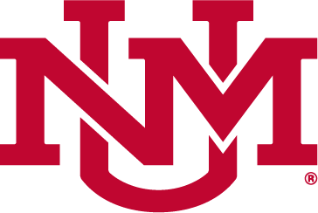  0.5” or larger only | 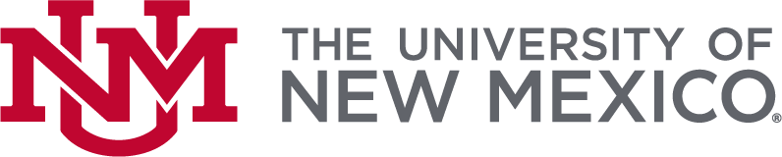  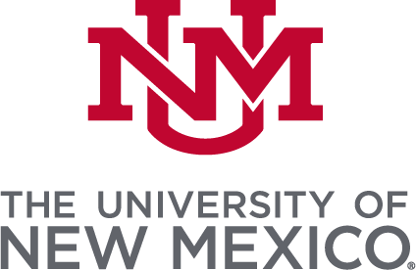

Unapproved UNM Logo Usage
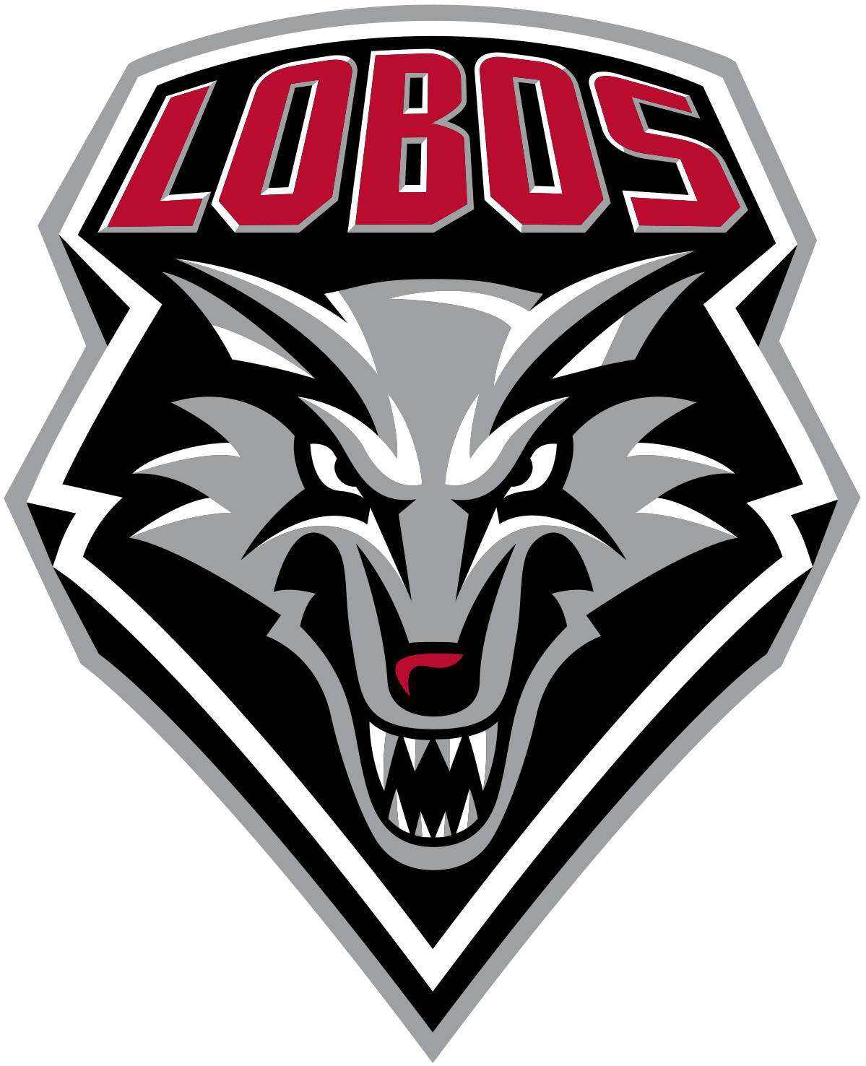 | 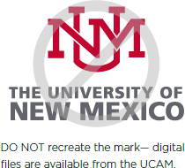 | 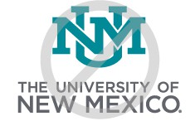 | 
UNM Athletics Logo cannot be used by Club Sports | Do not recreate the mark. Get the files from UCAM instead | Do not change the color of the mark | Do not use special fills, such as gradient fills.
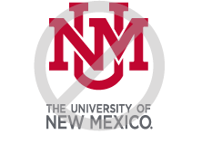 | 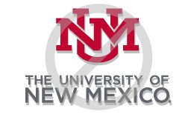 | 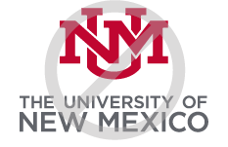 | 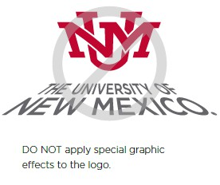
Do not distort the proportions of the elements of the logo | Do not add drop shadows to the logo | Do not remove or cover the registered trademark | Do not apply special graphic effects to the logo

UNM Brand Colors

Primary Colors
Cherry  HEX: #ba0c2f  CMYK: 20, 100, 75, 0  RGB: 186, 12, 47  PMS: 200 C | Turquoise  HEX: #007a86  CMYK: 95, 42, 47, 0  RGB: 0, 122, 134  PMS: 7713 C
Silver  HEX: #a7a8aa  CMYK: 40, 28, 25, 0  RGB: 167, 168, 170  PMS: Cool Gray 6 C  PMS Silver Metalic: 877C | Lobo Gray  HEX: #63666a  CMYK: 75, 65, 55, 0  RGB: 99, 102, 106  PMS: Cool Gray 10 C

Secondary Colors
High Noon  HEX: #ffc600  CMYK: 0, 17, 100, 0  RGB: 255, 198, 0  PMS: 7548 C | Sandia Sunset  HEX: #ed8b00  CMYK: 0, 50, 100, 0  RGB: 237, 139, 0  PMS: 144 C | Terra  HEX: #c05131  CMYK: 15, 85, 100, 0  RGB: 192, 81, 49  PMS: 7580 C
Mesa  HEX: #d6a461  CMYK: 12, 38, 72, 0  RGB: 214, 164, 97  PMS: 7509 C | Green Chile  HEX: #a8aa19  CMYK: 37, 14, 100, 0  RGB: 168, 170, 25  PMS: 383 C | Deep Dusk  HEX: #8a387c  CMYK: 45, 95, 5, 0  RGB: 138, 56, 124  PMS: 7656 C

Disciplinary Actions
The Club Sports Program at the University of New Mexico fosters leadership, teamwork, and healthy competition through student-led sports clubs. This policy establishes clear expectations for conduct and outlines a fair process for addressing violations to ensure a safe, inclusive, and respectful environment for all participants.
All Club Sports participants are expected to:
- Abide by university policies, Student Code of Conduct, local/state/federal laws, and Club Sports guidelines.
- Demonstrate respect for teammates, opponents, officials, staff, and facilities.
- Prioritize safety and good sportsmanship at all times.
- Use university privileges responsibly and ethically.
- Fulfill all administrative and operational requirements (e.g., rosters, travel forms, budget compliance).

Types of Violations

Minor Infractions (typically first offenses or administrative oversights):
- Late submission of forms (e.g., travel, roster)
- Failure to attend required meetings/workshops/orientations
- Missing deadlines without communication
- Uniform or equipment violations
- Minor unsportsmanlike conduct

Major Infractions (more serious or repeated behavior):
- Repeated administrative failures
- Holding unsanctioned events or practices
- Unauthorized field/facility use
- Inappropriate behavior during competition (e.g., verbal abuse, fighting)
- Financial mismanagement or policy violations
- Unauthorized travel

Severe Infractions (threaten program integrity or safety):
- Alcohol or drug use during club-sponsored travel, practice or any other event/outing in which the club is representing the university
- Hazing, harassment, or discrimination (including Title IX violations)
- Intentional dishonesty (e.g., falsified rosters or documents)
- Criminal activity

Consequences Framework
Consequences are determined by severity, intent, frequency, and impact. Sanctions may escalate for repeated offenses.

Minor Infractions
- 1st Offense: Verbal or written warning with corrective action plan
- 2nd Offense: Written action plan and leadership meeting
- 3rd Offense: Temporary facility or event restrictions

Major Infractions
- 1st Offense: Probation (4–8 weeks), required meeting with Club Sports staff
- 2nd Offense: Suspension from practices or events (1–4 sessions)
- 3rd Offense: Partial loss of funding and facility access

Severe Infractions
- Temporary suspension during investigation
If confirmed:
  - Permanent ban (individual)
  - Long-term club probation or loss of university club status

Appeals Process:
- Teams have the right to appeal against any disciplinary actions imposed against them.
- Appeals must be submitted in writing within a specified timeframe, outlining grounds for the appeal and providing any relevant evidence or documentation.
- Appeals will be reviewed by an impartial committee appointed by the program administrators, and their decision will be final.

